Solutions To Hands-On Exercises - Java Loops, Strings, Numbers and Dates

**Setup Instructions:**

1. Use the workspace - “Assignments” - in Spring Tool Suite IDE that you have created in the previous exercises .
2. Create a new Java Project called “DevOpsDay2”.
3. Create your classes in any package of your choosing.
4. Define your classes as given below for each assignment.

Assignment 01

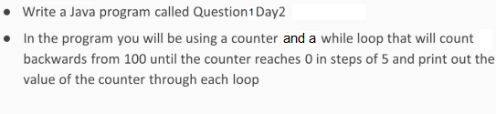

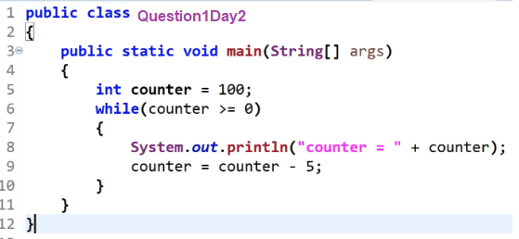

Output

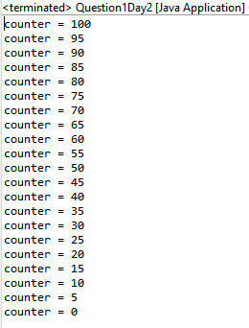

Assignment 02

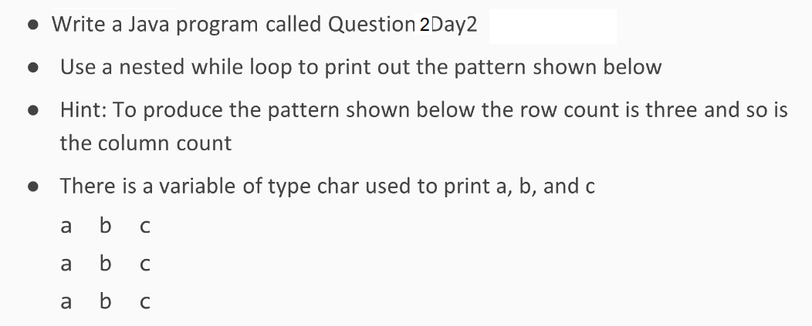

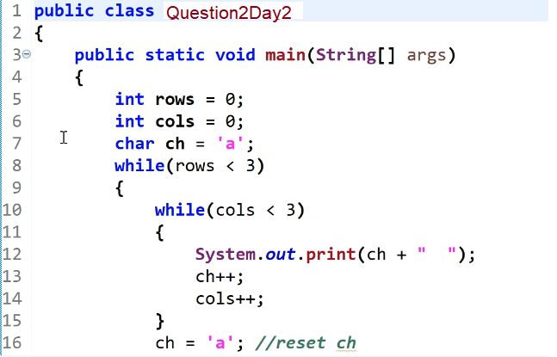

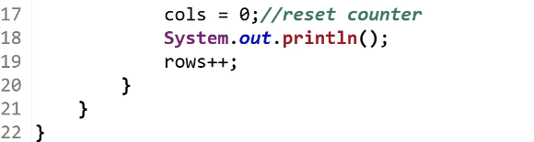

Output



